Invitation for conference meeting in connection to “Enviroconnect: Synergizing Green Resilience Efforts in Ivanovo and Piatra Olt”

The team of Project RoBg00146 is pleased to invite you to the opening conference organized on May 8th, 2025, in relation to the project.

The event will take place at the premises of the leading partner, Ivanovo Municipality, in the village of Ivanovo, at the municipal building on 75 Olimpiyska Street, in the Meeting room – 3rd floor. Start time: 12:00 PM.

We would be delighted to welcome you!

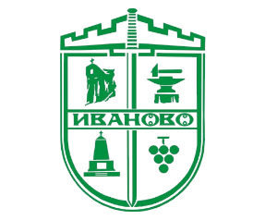

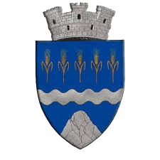

[**www.interregrobg.eu**](http://www.interregrobg.eu/)

